ANOVA Analysis of Supply Chain Efficiency and Product Quality
Feifei Li & Kathryn Stoven
STAT 301 | Metro State University | April 2026

Introduction
Efficient supply chain management requires understanding factors that influence both production costs and product quality. In this project, a supply chain logistics dataset was analyzed using ANOVA methods to investigate whether product type affects manufacturing costs and whether transportation mode and product type jointly influence defect rates.
Two research questions were developed using variables appropriate for analysis of variance methods.

Research Question 1
Does product type significantly affect manufacturing costs?
- Response Variable (DV): Manufacturing Costs (continuous)
- Explanatory Variable (IV): Product Type (cosmetics, haircare, skincare)
Hypotheses:
$$H_{0}:μ_{cosmetics}=μ_{haircare}=μ_{skincare} \\ H_{a}: At least one product type mean is different from the others$$Research Question 2
Do transportation mode and product type interact to affect defect rates?
- Response Variable: Defect Rates (continuous)
Factors:
- Transportation Mode (Air, Rail, Road, Sea)
- Product Type (Haircare, Cosmetics, Skincare)
Main effects of transportation mode & Product type:
$$H_{0}: μ_{Air}=μ_{Rail}=μ_{Road}=μ_{Sea} \\ H_{a}: \text{At least two means are different. }$$

$$H_{0}:μ_{Haircare}=μ_{Cosmetics}=μ_{Skincare} \\ H_{a}: \text{At least two means are different.}$$
Interaction hypotheses:
$$H_{0}:\text{There is no interaction that exists between transportation mode and product type} \\ H_{a}:There is \text{an interaction that exists between transportation mode and product type}$$

Methods

Data Cleaning and Processing
The dataset was imported into R from the original Kaggle CSV. Four ambiguous column names were renamed (e.g., Lead.times → Supplier_Lead_Time, Costs → Total_Costs). No missing values and no duplicate rows were found. All categorical variables were converted to R factors. An IQR-based outlier scan identified no extreme values. All 100 observations and 24 variables were retained in the cleaned dataset Cleaned_Supply_Chain_Data.

Choice of Analysis
Question 1 uses a one-way ANOVA because there is one categorical IV (Product Type, three levels) and one continuous DV (Manufacturing Costs). ANOVA is chosen over multiple pairwise t-tests because running three t-tests at α = 0.05 inflates the Type I error rate. ANOVA controls this with a single F-test . Post-hoc TukeyHSD comparisons are only performed if the F-test is significant (p < 0.05).
Question 2 uses a two-way ANOVA with interaction because there are two categorical IVs (Transportation Mode and Product Type) and one continuous DV (Defect Rates), forming a 4×3 factorial design. The design is unbalanced (see Table 2), so Type II sums of squares are applied via the Anova() function from the car package, which is order-independent and appropriate for unbalanced designs. When the interaction is significant, a simple-effects analysis is conducted: one-way ANOVA is run within each transportation mode to compare product types.
Table 2: Cell Counts — Transportation Mode × Product Type
Transport Mode | Cosmetics | Haircare | Skincare | Total
Air | 5 | 8 | 13 | 26
Rail | 9 | 10 | 9 | 28
Road | 6 | 12 | 11 | 29
Sea | 6 | 4 | 7 | 17
Total | 26 | 34 | 40 | 100
Note: Cell sizes range from 4 to 13 — unbalanced design requiring Type II .

Conclusion

Question 1: One-Way ANOVA — Product Type vs. Manufacturing Costs
Table 1: One-Way ANOVA Results — Manufacturing Costs by Product Type
Source | df | Sum Sq | Mean Sq | F value | p-value
Product Type | 2 | 629.0 | 314.6 | 0.370 | 0.692
Residuals | 97 | 82531.0 | 850.8 | — | —
Note: α = 0.05. ns = not significant.

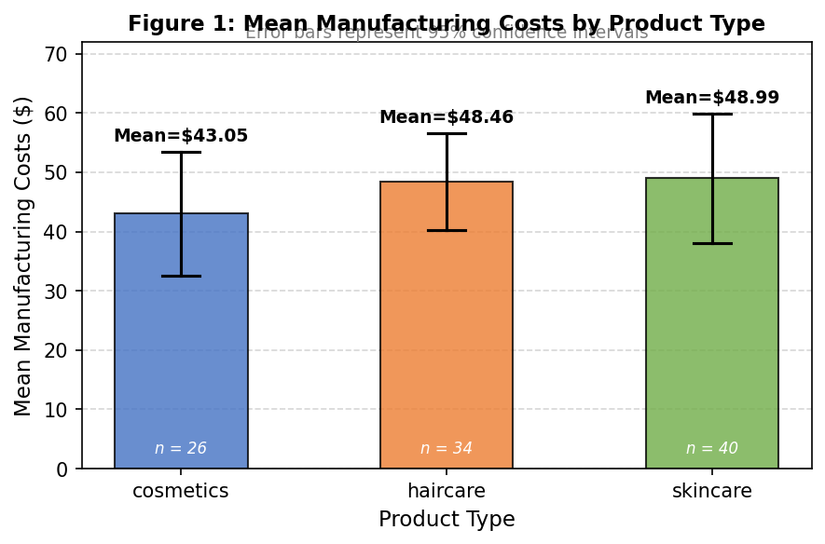
Figure 1: Mean Manufacturing Costs by Product Type with 95% CIs. Mean values labeled above error bars.
Interpretation
Test statistic: F = 0.370, p = 0.692.
Since p = 0.692 > 0.05, we fail to reject $H_{0}$. There is no statistically significant difference in mean manufacturing costs across product types; Although average costs vary slightly, those differences are small relative to within-group variability. No post-hoc testing is needed.

Question 2: Two-Way ANOVA — Transportation Mode × Product Type vs. Defect Rates
Table 3: Two-Way ANOVA (Type II SS) —
Defect Rates by Transportation Mode and Product Type
Source | df | Sum Sq | F value | p-value | Significance
Transportation Mode | 3 | 9.07 | 1.61 | 0.193 | ns
Product Type | 2 | 5.13 | 1.37 | 0.261 | ns
Mode × Type (Interaction) | 6 | 32.00 | 2.84 | 0.014 | * sig.
Residuals | 88 | 165.45 | — | — | —
Note: ns = not significant; * = significant at α = 0.05.
Transportation Mode: F = 1.61, p-value = 0.193 > 0.05 → fail to reject $H_{0}$.
Product Type: F = 1.37, p-value = 0.261 > 0.05 → fail to reject $H_{0}$.
Interaction: F = 2.84, p-value = 0.014 < 0.05 → REJECT H₀. There is significant interaction between transportation mode and product type.
Interpretation: The effect of transportation mode on defect rates depends on product type. A transportation mode associated with low defect rates for one product category may not perform similarly for another, suggesting transportation decisions should be product specific.
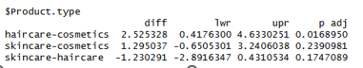
Figure 2: Interaction Plot — Mean Defect Rate by Transportation Mode and Product Type. Lines diverge sharply under Air (cosmetics ~0.40 vs. haircare ~2.92), confirming the significant interaction (p = 0.014).
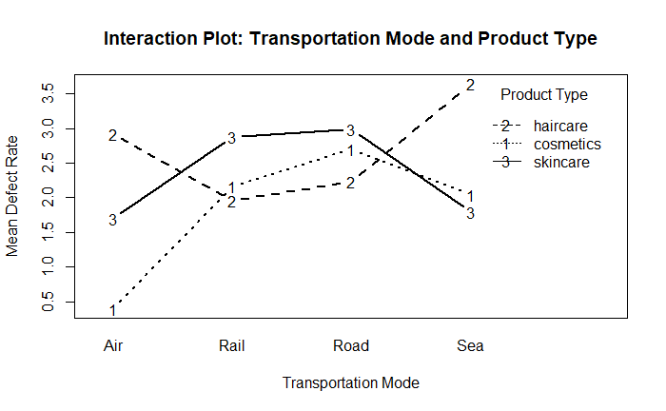
Interpretation: Post-hoc simple-effects ANOVA and TukeyHSD results show this is driven by Air mode, where haircare products have significantly higher defect rates than cosmetics.

Most Interesting Finding
The most notable finding is that neither transportation mode nor product type had a significant main effect individually, yet their interaction was significant. This indicates important relationships would have been missed had only main effects been examined. This also demonstrates the value of factorial ANOVA in supply chain decision-making.
From a management perspective, air transportation should be used with caution for haircare products, and uniform logistics policies applied across all product types may conceal important quality risks.

Limitations
Several limitations should be considered:
- The dataset is observational, limiting causal conclusions.
- Other variables such as suppliers, production volume, or region were not included.
- Unequal group sizes may affect precision in some estimates.
- Results may not generalize beyond this dataset.
References
Amirmotefaker. (n.d.). Supply chain analysis [Kaggle notebook]. Retrieved from https://www.kaggle.com/code/amirmotefaker/supply-chain-analysis/input

GitHub Repository

https://github.com/TogetherWeDoBetter/STAT301-SupplyChain-ANOVA

